AI ASSISTED CODING

ASSIGNMENT 3.2

**ENROLLMENT NO**: 2503A51L35

**BATCH NO**:20

**NAME**: MOHAMMED MUTAKABIR HUSSAIN

**Task 1:**

**Description :**

**Ask AI to write a function to calculate compound interest, starting with only the function name. Then add a docstring, then input-output example**

**Prompt:**

“Write a Python function to calculate compound interest. Start by providing only the function name. Next, add a docstring that explains what the function does, its parameters, and its return value. Then, include an input-output example that demonstrates how to use the function and what result it produces." implement with example

**Code :**

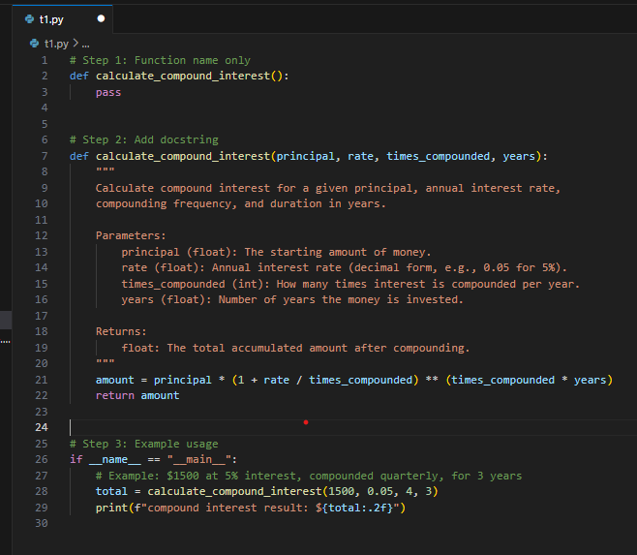

Output:

**Task 2:**

**Description:**

**Do math stuff, then refine it to: # Write a function to calculate average, median, and mode of a list of numbers**

**Prompt:** **generate a python function to calculate average, median, and mode of a list of numbers that should be enter at runtime**

**Code:**

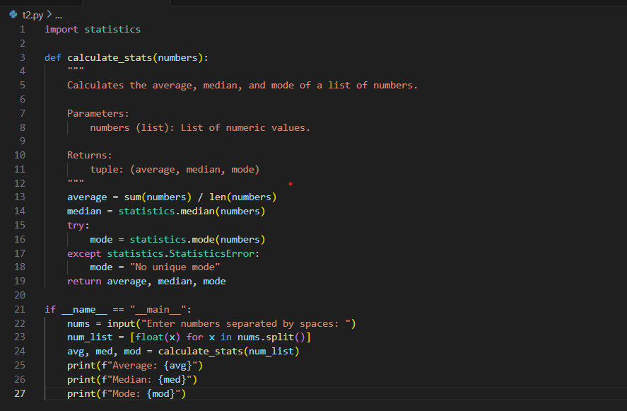

**Output:**

**Task 3:**

**Description:**

**Provide multiple examples of input-output to the AI for convert_to_binary(num) function. Observe how AI uses few-shot prompting to generalize.**

**Prompt:**

**generate a python program that provides multiple input–output examples for a Python function convert_to_binary(num) that converts a decimal number into its binary representation**

**code:**

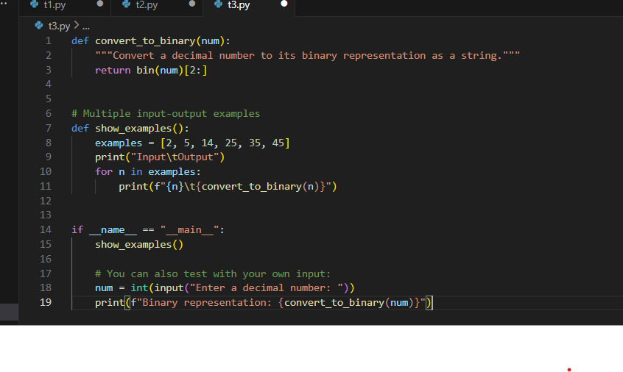**Output:**

**Task 4:**

**Description:**

**Create an user interface for an hotel to generate bill based on customer requirements**

**Prompt: Generate a python program to Create an user interface for an hotel to generate bill based on customer requirements**

**Code:**

**Output:**

**Task 5:**

**Description:**

**Analyzing Prompt Specificity: Improving Temperature Conversion Function with Clear Instructions**

**Prompt: Generate a python program to Improving Temperature Conversion Function with Clear Instructions**

**Code:**

Output:

**Observation**

From this assignment, I realized the practical importance of **prompt engineering** and **AI-assisted coding** in creating Python programs. By varying the type and detail of instructions, the AI was able to generate complete code solutions, add examples, and even build user-friendly features.

* **Task 1:** Beginning with only a function name and then step-by-step adding docstrings and examples showed how AI can systematically construct programs from minimal instructions.
* **Task 2:** Using runtime inputs for calculations like average, median, and mode demonstrated how AI can handle mathematical operations based on user data.
* **Task 3:** Providing multiple input–output pairs for the convert_to_binary(num) function highlighted how few-shot prompting helps AI generalize and produce correct binary conversions for any number.
* **Task 4:** The hotel billing program illustrated AI’s ability to go beyond simple logic and create more practical, user-oriented applications by combining programming logic with interface design.
* **Task 5:** Refining the temperature conversion function emphasized how the **specificity of prompts** directly improves the correctness, clarity, and overall usability of AI-generated solutions.